Ex.No: 5
Ansible-Deployed GraphQL API for Task Management with Node.js

1. AIM
To create a GraphQL API for Task Management Application and deploy it using Ansible.

2. POSSIBLE IDEAS
- Automate Environment Setup with Ansible — Use Ansible playbooks to automate the installation of Node.js, npm, and required packages on the target server for consistent deployment.
- Deploy GraphQL Server Code with Ansible Tasks — Create tasks in Ansible to clone the Node.js GraphQL project from a Git repository and install dependencies using npm install.
- Manage Application Services with Ansible + PM2 — Use Ansible to install and configure PM2 (Node.js process manager) to keep the GraphQL API running in the background and auto-restart on crashes.
- Set Up Environment Variables and Configs — Use Ansible templates or variables to manage environment-specific settings such as the database URL, port, and JWT secret.
- Configure Firewall and Reverse Proxy (Optional) — Add Ansible roles to configure Nginx or UFW to expose the GraphQL API securely through a reverse proxy and open only necessary ports.
Note: The supplied lab manual lists Node.js/npm installation and MongoDB installation as commented-out tasks in the sample playbook. Therefore, the deployment environment must already provide any dependencies that remain commented out, or those tasks must be enabled and configured for the target environment.

3. SAMPLE ALGORITHM
- Set Up Ansible Inventory and Playbook — Define the target server in the inventory file and create an Ansible playbook to automate deployment steps.
- Install Required Packages on Remote Server — Use Ansible tasks to install Node.js, npm, Git, and other dependencies on the target machine.
- Deploy GraphQL API Code — Clone the Node.js GraphQL API project from a Git repository and run npm install to set up the project on the server.
- Configure and Start the Server — Set up environment variables and use Ansible to run the server using PM2 or Node directly.
- Verify Deployment and Access API — Confirm that the server is running and accessible through the specified port or domain, then test GraphQL queries and mutations.

4. SOFTWARE / TOOLS REQUIRED
- Node.js and npm
- Ansible
- Git
- PM2 (Node.js process manager)
- The GraphQL task-management application from the previous GraphQL task-management experiment, stored in a Git repository
- Ubuntu/Debian environment for the supplied APT-based playbook (local or remote target)
- A web browser with access to the GraphiQL/GraphQL endpoint
Note: The sample playbook uses apt, connection: local, and become: yes. If you execute it on a different operating system, adapt the package-management and privilege-escalation tasks to that environment.

5. PREREQUISITE: VERIFY THE GRAPHQL APPLICATION
Experiment 5 deploys the GraphQL task-management application; it does not define a new GraphQL schema in the Ansible playbook. Before running Ansible, make sure the application repository contains the Node.js GraphQL project and that the application's startup file is available at src/app.js, as referenced by the supplied playbook.
- Open the GraphQL task-management project used for the earlier experiment.
- Confirm that package.json exists and contains the required project dependencies.
- Confirm that src/app.js exists. The supplied Ansible playbook starts this file using PM2.
- Confirm that the project can be obtained from a Git repository.
- Confirm the application port and database configuration used by your project.
Note: The supplied Experiment 4 server code uses a GraphQL endpoint at /graphql and defaults to port 5000. If your project has a different configuration, use that project's actual endpoint and port.

6. PROJECT / ANSIBLE SETUP

Step 6.1 — Create a deployment folder
Create a working directory for the Ansible deployment and place the playbook inside it.
mkdir graphql-ansible
cd graphql-ansible
touch Deploy.yml

Note: On Windows, run the commands in an Ubuntu/WSL terminal if you are using the supplied APT-based playbook.

Step 6.2 — Create the deployment playbook
Create Deploy.yml. The playbook follows the exact deployment sequence given in Experiment 5: update APT, clone the repository, install project dependencies, install PM2, start the application, and save the PM2 process list.

Step 6.3 — Working playbook
Use the following formatted version of the Experiment 5 playbook. Replace the repository placeholder with the actual Git repository containing your GraphQL task-management project.
- hosts: localhost
connection: local
become: yes
tasks:
- name: Update APT package manager
apt:
update_cache: yes
cache_valid_time: 3600
- name: Clone the repository
git:
repo: 'https://github.com/<YOUR-USERNAME>/<YOUR-REPOSITORY>.git'
dest: /var/www/task-manager-api
version: main
- name: Install project dependencies
npm:
path: /var/www/task-manager-api
state: present
- name: Install PM2 globally
npm:
name: pm2
global: yes
- name: Start the application with PM2
command: pm2 start src/app.js --name task-manager
args:
chdir: /var/www/task-manager-api
- name: Save PM2 process list
command: pm2 save
Deploy.yml

Note: The repository URL shown in the extracted lab-manual text is incomplete/malformed. Do not copy it literally; replace it with the actual Git URL for your task-management repository.

7. UNDERSTANDING EACH ANSIBLE TASK
Update APT package manager — Refreshes the package metadata and keeps the cache valid for 3600 seconds.
Clone the repository — Copies the GraphQL project from the Git repository into /var/www/task-manager-api and checks out the main branch.
Install project dependencies — Runs the npm dependency installation for the cloned Node.js project.
Install PM2 globally — Installs PM2 as a global npm package so it can manage the Node.js application.
Start the application with PM2 — Starts src/app.js under the PM2 process name task-manager and sets the working directory to the deployed project.
Save PM2 process list — Saves the current PM2 process list after the application has been started.

8. RUNNING THE ANSIBLE DEPLOYMENT

Step 8.1 — Check Ansible
ansible --version

If Ansible is available, its version information will be displayed.

Step 8.2 — Check the playbook syntax
ansible-playbook Deploy.yml --syntax-check

A successful syntax check confirms that the YAML structure can be parsed before deployment.

Step 8.3 — Execute the playbook
ansible-playbook Deploy.yml

Because the supplied playbook uses hosts: localhost and connection: local, the tasks are executed against the local Ubuntu/Debian environment. The become: yes setting may request administrative privileges.

Step 8.4 — Observe the Ansible recap
At the end of execution, Ansible prints a PLAY RECAP. The supplied experiment screenshot shows localhost completing the deployment tasks without failed or unreachable tasks.

9. VERIFY THE PM2 PROCESS
pm2 list
pm2 status

Look for the task-manager process in the PM2 process list. If it is running, the GraphQL application has been started under PM2.

10. VERIFY THE GRAPHQL APPLICATION
- Open the browser and navigate to the GraphQL endpoint used by your application.
- For the Experiment 4 server configuration supplied in the lab manual, the endpoint is /graphql and the default port is 5000.
- Use the GraphiQL interface to execute a task-list query.
The sample output in the lab manual shows a GraphiQL query requesting the task id, jobtodo, and toggle fields:
query {
msglist {
id
jobtodo
toggle
}
}

The corresponding sample response displays two task records, including values such as assignment and record, each with an id and toggle value.

11. TEST THE TASK MANAGEMENT APPLICATION

Test 1 — Read the task list
- Open the GraphiQL page.
- Enter the msglist query shown above.
- Click the Run/Play button.
- Confirm that the response contains the task list with id, jobtodo, and toggle fields.

Test 2 — Verify the deployed process
- Return to the terminal running the deployment environment.
- Run pm2 list.
- Confirm that task-manager is present and online/running.
- If the process is not running, inspect the PM2 logs with pm2 logs task-manager.

12. EXPECTED DEPLOYMENT FLOW
Ansible Playbook
|
v
Update APT cache
|
v
Clone GraphQL project
|
v
Install npm dependencies
|
v
Install PM2
|
v
Start src/app.js with PM2
|
v
Save PM2 process list
|
v
Open GraphQL endpoint /graphql
|
v
Run task-management query

13. TROUBLESHOOTING
Repository clone fails — Check the Git URL, repository visibility/access, branch name, and network connection. The source playbook uses version: main.
Permission denied for /var/www — The supplied playbook uses become: yes. Ensure the execution environment allows privilege escalation.
npm task fails — Check that Node.js/npm is installed in the target environment. In the supplied manual, the Node.js/npm installation lines are commented out.
PM2 cannot start src/app.js — Confirm that src/app.js exists in /var/www/task-manager-api and that the project dependencies have been installed.
GraphQL page does not load — Check pm2 status, inspect pm2 logs task-manager, and verify the application's configured port and /graphql route.
Database connection fails — Check the database configuration/environment variables used by the GraphQL application. The Experiment 5 playbook itself does not configure the database.

14. SAMPLE PROGRAM — SOURCE VERSION
The following is the deployment sequence represented in the supplied Experiment 5 manual. The repository line is reproduced as a placeholder because the extracted source text is incomplete.
- hosts: localhost
connection: local
become: yes
tasks:
- name: Update APT package manager
apt:
update_cache: yes
cache_valid_time: 3600
# - name: Install Node.js and npm
# ...
# - name: Install MongoDB
# ...
- name: Clone the repository
git:
repo: '<YOUR ACTUAL GRAPHQL REPOSITORY URL>'
dest: /var/www/task-manager-api
version: main
- name: Install project dependencies
npm:
path: /var/www/task-manager-api
state: present
- name: Install PM2 globally
npm:
name: pm2
global: yes
- name: Start the application with PM2
command: pm2 start src/app.js --name task-manager
args:
chdir: /var/www/task-manager-api
- name: Save PM2 process list
command: pm2 save
Experiment 5 sample deployment structure

15. SAMPLE OUTPUT
The supplied Experiment 5 manual shows two screenshots on page 44: the Task Management System web interface and a GraphiQL query/response window. The screenshots demonstrate the deployed task-management application and the returned task list.
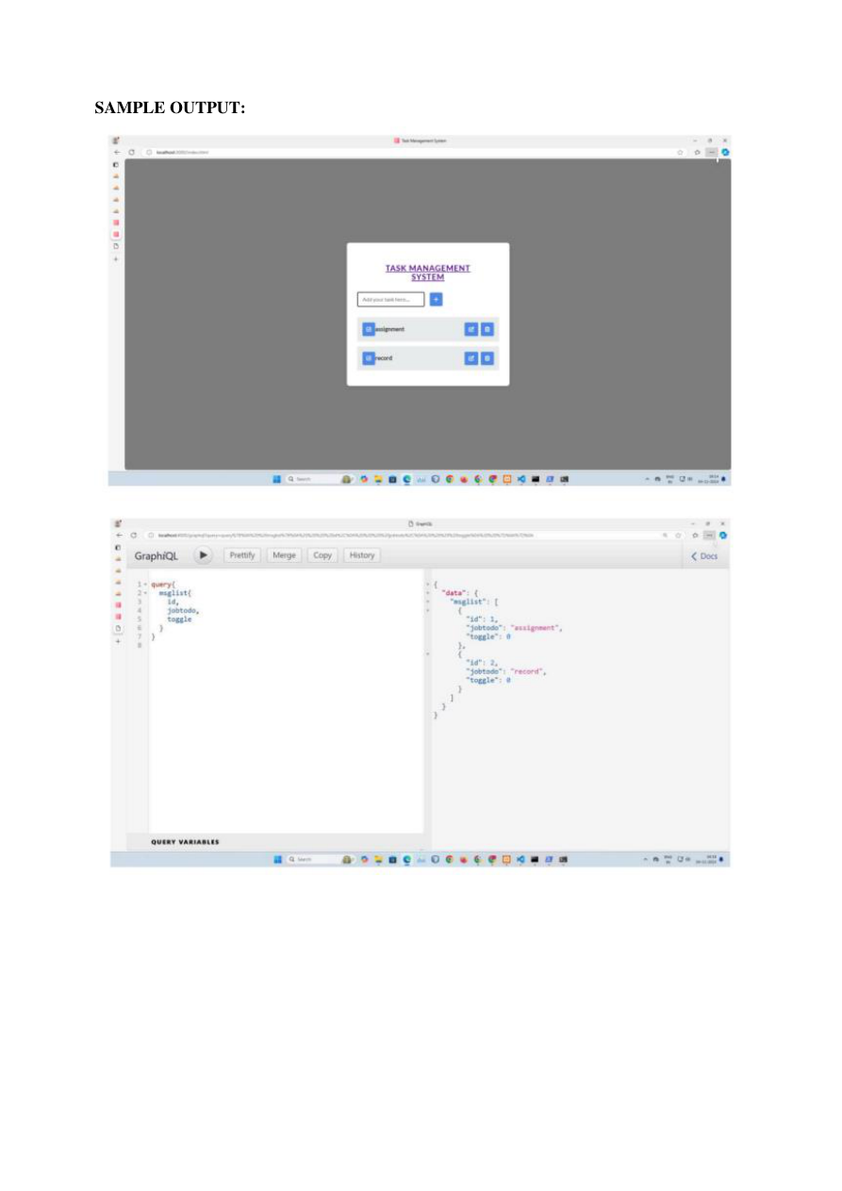
In the GraphiQL screenshot, the query requests msglist fields id, jobtodo, and toggle, and the response shows task entries including assignment and record.

16. RESULT
The GraphQL API for the task management application was successfully deployed using Ansible, automating the setup and deployment process.

17. QUICK COMMAND REFERENCE
ansible --version
ansible-playbook Deploy.yml --syntax-check
ansible-playbook Deploy.yml
pm2 list
pm2 status
pm2 logs task-manager

